Adding a Printer
Select “Devices and Printers”
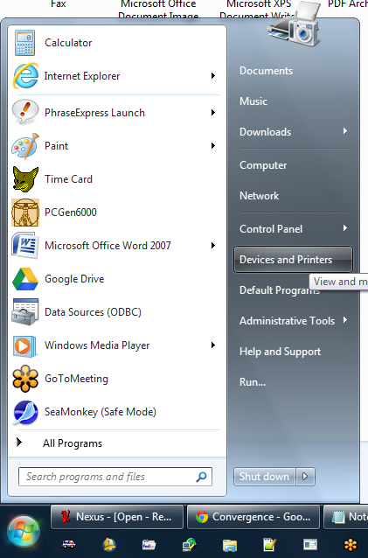

Select “Add New Printer”
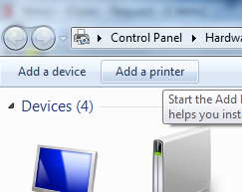

Select “Add a network, wireless, or Bluetooth Printer”
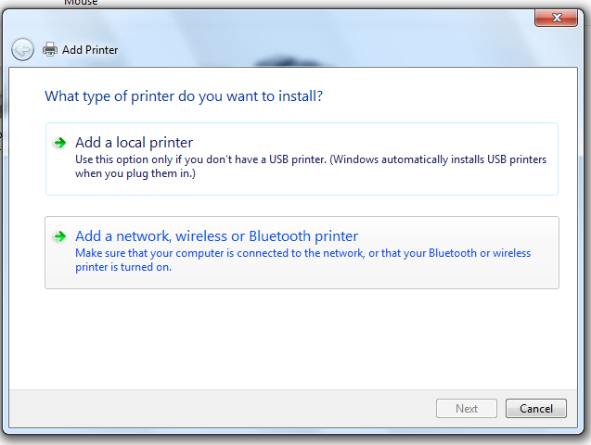

Select “The Printer wasn’t listed”
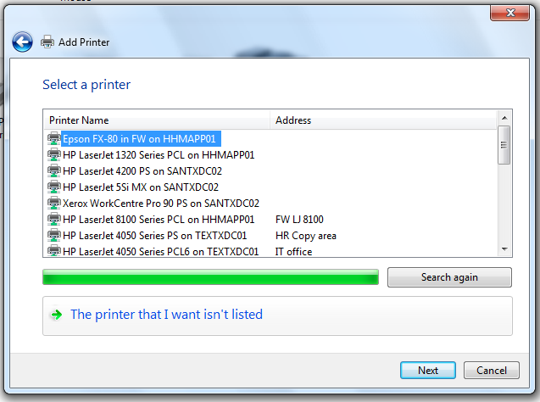
Select “Find a printer in the directory, based on location for feature”
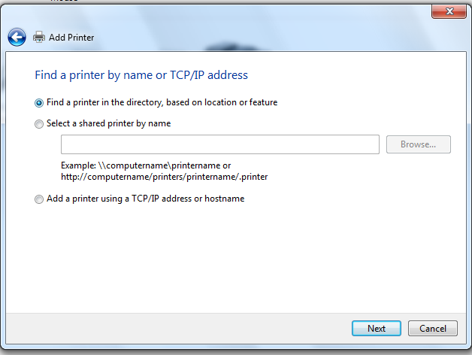

Enter in the Printer details:
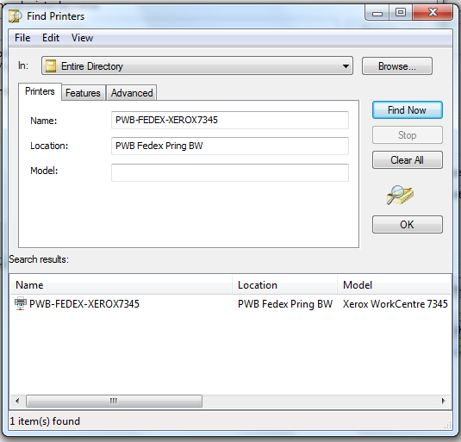
Enter “PWB-FEDEX-XEROX7345” into the Name.
Enter “PWB Fedex Pring BW” into the Location
Press “Find Now”
Select it below “Name” and press OK.

